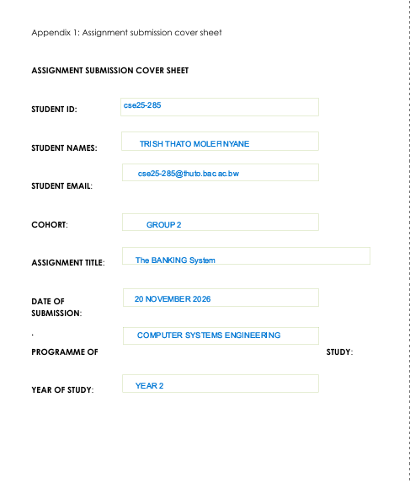
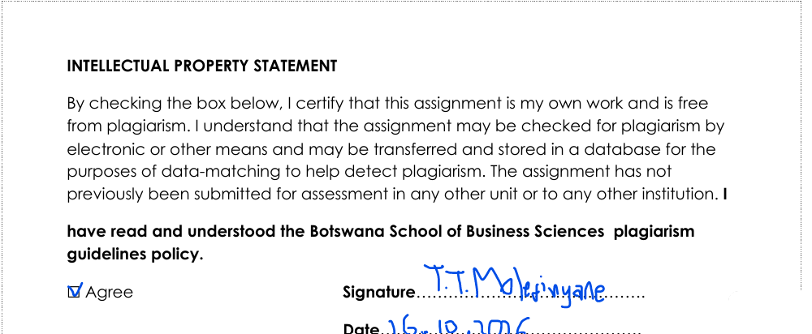
16/10/2026

Part A:
FUNCTIONAL REQUIREMENTS
The System Must:
- Allow a customer to open a new account with the bank and it can be more than one accounts (provided ID is valid) .
- Allow customers to withdraw cash, check or transfer deposit into any active account.
- Ensure interest is paid to the appropriate accounts of customer automatically i.e. 5% monthly per Investment Account and 0.05% monthly per Savings Account.
- Allow customer to view transaction history
- Allow secure login with password and registration with two step authentications
- Allow customers to view balances and account details
- Not allow customers to withdraw from savings if the agreed period hasn’t been reached
- Allow the customer to receive funds from other customers
- Manage the customer's account by asking customers to set a limit to their daily withdrawals
MOCK INTERVIEW
Developer: what processes does a new customer go through?
Client: For new customers-after installing the application, they must register with us virtually but for that we need their personal details, that is for individuals; identity card number or passport number for international customers, full names, date of birth, physical address, email address, postal address, source of income statements, work status info / employment details, cellphone number. For companies/businesses; company registration information, information of the shareholders(; identity card number or passport number for international customers, full names, date of birth, physical address, email address, postal address, source of income statements, work status info / employment details, cellphone number), company profile, turnover is needed
Developer: What about returning customers?
Client: If an individual has already been registered, they choose the login option and proceed to type in their account number and password.
Developer: can a single customer have multiple accounts?
Client: yes, in our bank a customer can have more than 1 type of accounts.
Developer: Regarding a customer being able to open multiple accounts, which accounts / what types of accounts can a customer hold and how do they operate?
Client: We offer:
1. Savings Account: Designed strictly for saving. In this account money can be deposited anytime but it earns 0.05% interest monthly and withdrawal is strictly forbidden; a customer can withdraw once every 2 years.
2. Investment Account: Designed mainly for higher returns with an interest rate of 5.00% per month, it allows withdrawals & deposits and can only be set up with a minimum deposit of P500. A customer can withdraw once every 6 months.
3. Cheque Account: Used for salary credits. Anyone with a reliable source of income can have it. Both deposits and withdrawals of any amount are permitted anytime.
Developer: How should transactions be addressed/processed for withdrawals?
Client: Deposits apply to all accounts whilst for withdrawals, the system checks for the account being used and checks the rule of withdrawing funds i.e.
- If the account is for Savings and 2-year period is not reached or If account is investment and 6 months period is not reached then display an error message "WITHDRAWAL IS NOT ALLOWED ON THIS ACCOUNT" and close transaction otherwise continue withdrawing.
- If account is investment or cheque account: Compare the amount to be withdrawn with amount available in the account, if the amount withdrawn is less than amount available then proceed with transaction otherwise terminate transaction.
Developer: How is customer information protected from malicious intents ?
Client: we protect personal information by legislation, only authorized people are allowed to access specific information-admin can access every data and data encryption
Developer: how will you make sure your system is user friendly to elderly people ?
Client: We have physical human bank tellers to help illiterate people.
Developer: Will customers be able to view transaction history and what will be in the transaction history detail??
Client: Yes, customers will be able to view transaction history and it will include timestamp on each record and the records should not be changeable, the record should show details like amount, transaction type, if it was transferring money then include the receivers names and account number, and also Customer Data should be encrypted.
NON-FUNCTIONAL REQUIREMENT
SECURITY:
- Customers password and details should be encrypted
  - Show only necessary and simple information and hide complex implementation and only show sensitive information after inputting correct password

PERFORMANCE:
- Respond / loading time should be within 300-500 milliseconds
  - System should process transaction and calculate interest as quickly as possible
USABILITY
- System must be user friendly i.e. clear and easy human readable
  - interactions and shouldn’t need the customer to have technical experience

RELIABILITY
- Calculations should be reliable and consistent, balances should be synchronized with transactions, and transaction history should be permanent
  - Failed operations take user back to start, and data integrity must be maintained
- Change in another users view shouldn’t affect another view

MAINTAINABILITY
- The system should be designed using modular and object-oriented principles so that each component can be updated independently and easily
- The system should provide comprehensive user and technical documentation.

USE CASE
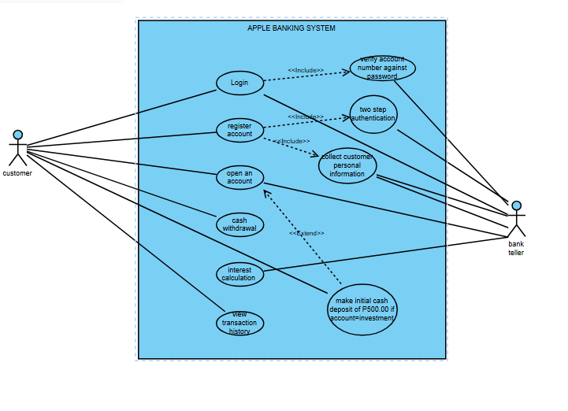

CLASS DIAGRAM
